Project Documentation: Parch and Posey Sales Analytics
Prepared by: Umanah Emmanuel
Date: April 21, 2026
To: Mr. Thompson, VP of Sales
From: Junior Data Analyst

1. Executive Summary (1 Page)
This project provides a comprehensive end-to-end analysis of Parch and Posey’s sales operations. By consolidating data from SQL Server and transforming it into an interactive Power BI dashboard, we have addressed historical visibility gaps, allowing for rapid decision-making.
Key Findings:
- Total Performance: The company has generated $23.14M in total revenue, supported by 351 unique customers.
- Product Drivers: Standard Paper remains the dominant revenue driver, accounting for 41.8% of total sales.
- Growth Trends: Analysis indicates a strong upward trajectory, with Q4 consistently emerging as the highest-performing period, particularly in 2014 and 2015.
- Engagement Correlation: Digital engagement is a strong leading indicator of sales; top-revenue customers exhibit significantly higher web activity, validating our digital marketing investments.
Top Recommendations:
- Prioritize Q4 Strategy: Capitalize on the Q4 surge by launching targeted promotions in late Q3.
- Engagement-Based Sales: Focus sales representative outreach on accounts showing high web engagement but low order frequency.

2. Methodology (1 Page)
Data Extraction:
Data was extracted from the Parch and Posey SQL Server database. 12-15 specific queries were designed to answer business-critical questions, utilizing JOINs, GROUP BY, and HAVING clauses to ensure data integrity and accurate extraction.
Data Transformation:
- Cleaning: Performed in Power Query: removed lat/lon columns, handled NULL values by replacing them with "N/A" If any but found non, trimmed whitespace, and ensured proper capitalization.
- Quality Control: Validated using Column Distribution and Profile tools to ensure data accuracy.
- Standardization: Fixed data types (Date/Time, Decimal, Whole Numbers) and maintained column naming consistency.
Data Modeling:
- Star Schema Architecture: Transitioned from a snowflake schema to a Star Schema by denormalizing dimensions into fact tables (orders and web_events) to optimize performance and report interactivity.
- Time Intelligence: Implemented a dedicated Calendar table to bridge the relationship between orders and web_events, resolving initial date-relationship conflicts.

3. Dashboard Overview (3 Pages)
Page 1: Sales Performance Overview
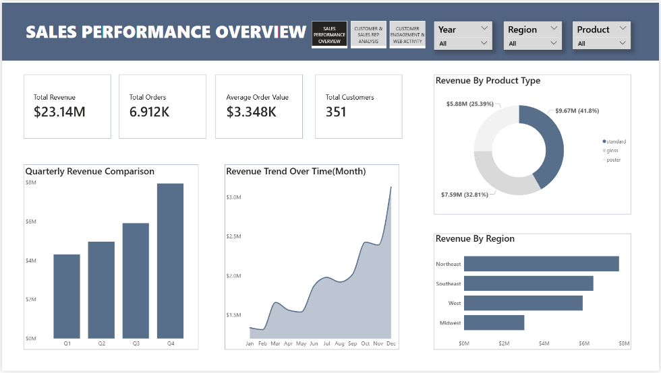
- Business Answers: Revenue is $23.14M, trending upward. Standard Paper is the top product. Q4 of 2014/2015 was the strongest performance period.
What is our total revenue and how has it trended over time?
- Answer: Total revenue is $23.14M. The revenue trend shows a consistent upward trajectory over time, with significant acceleration recorded throughout the fiscal years.
Which product types generate the most revenue?
- Answer: Standard Paper is the top revenue generator, accounting for 41.8% ($9.67M) of total sales, followed by Gloss (32.8%) and Poster (25.39%).
How are sales distributed across the four regions?
- Answer: Revenue is distributed across all four regions (Northeast, Southeast, West, Midwest). The Northeast region currently holds the highest share of total revenue.
Which periods show the strongest sales performance?
- Answer: The fourth quarter (Q4) consistently shows the strongest sales performance. While 2016 recorded the highest volume of orders (nearly 4,000), it also represents the peak annual revenue at approximately $13M.
Page 2: Customer & Sales Rep Analysis
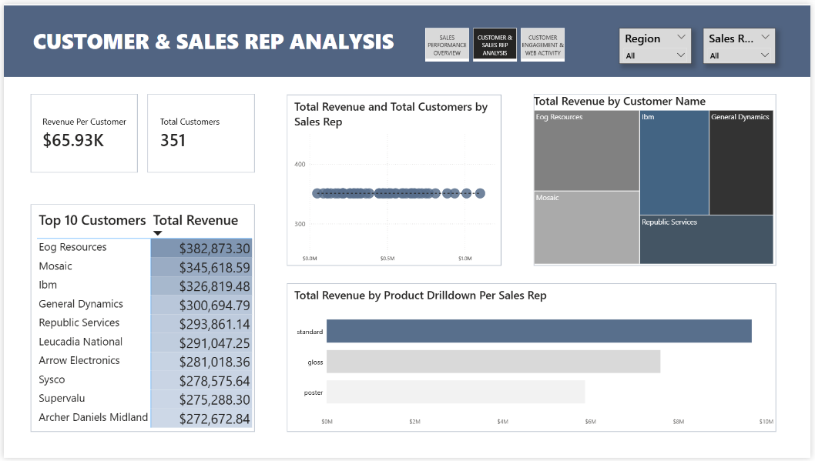
- Business Answers: Eog Resources, Mosaic, and Ibm are our most valuable customers. Revenue is concentrated, and we recommend pivoting evaluation metrics to "revenue-per-account."
Who are our most valuable customers?
- Answer: Our top-tier customers are led by Eog Resources ($382k), Mosaic ($345k), and Ibm ($326k).
Which sales representatives are top performers?
- Answer: Performance is consistent across the team. By utilizing the Product drilldown, we identify that the total revenue contribution peaked significantly in Standard across all sales representatives.
How is revenue distributed across the customer base?
- Answer: Revenue distribution is concentrated, with a small number of high-value accounts contributing a disproportionately large share of total revenue.
Which accounts show growth potential?
- Answer: Accounts that appear in the top 10 revenue list with increasing order frequency over time indicate the highest growth potential for future account management.

Page 3: Customer Engagement & Web Activity
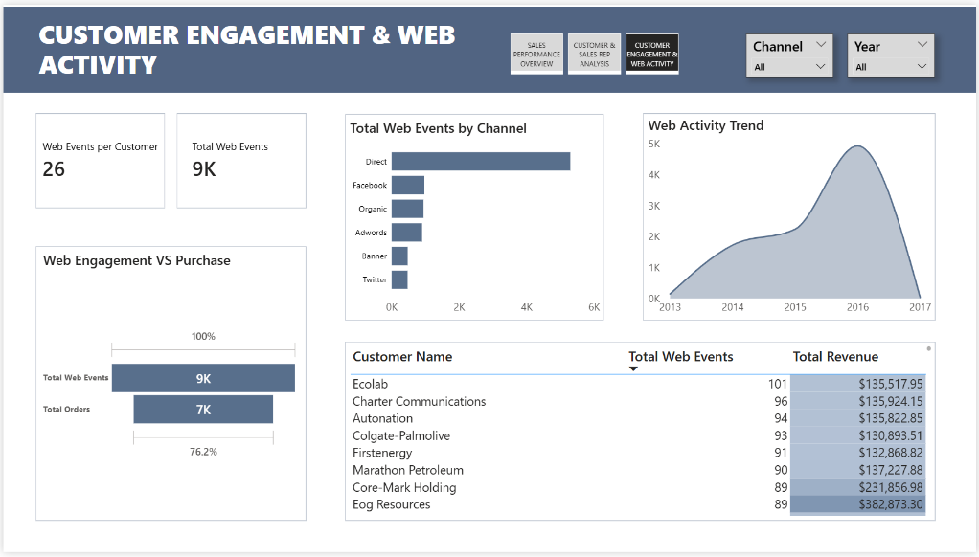
Business Answers: Direct traffic is the leading channel. A strong positive correlation exists between web events and sales.
What are the most popular engagement channels?
- Answer: Direct traffic is the primary engagement channel by a significant margin, followed by Facebook, Organic search, and Adwords.
Is web activity correlated with sales?
- Answer: Yes, there is a strong positive correlation. Accounts with high web event counts (e.g., Ecolab, Charter Communications) consistently rank within the top revenue-generating accounts.
Which customers engage heavily but purchase minimally?
- Answer: Accounts with high web engagement (e.g., >80 events) that fall outside the top 10 revenue list represent "High Potential" accounts that require targeted sales follow-up.
How is engagement trending over time?
- Answer: Web engagement trended steadily upward from 2013, peaking in 2016, mirroring the surge in total revenue and order volume during that same period.

4. Key Insights
- Section 4: Key Insights & Actionable Recommendations
I. Major Trends
- Revenue Concentration: Our analysis reveals that revenue is highly concentrated within a small subset of the customer base. A critical segment of top-tier accounts, led by Eog Resources and Mosaic, contributes a significant portion of our $23.14M total revenue. This concentration indicates that our business model is highly reliant on key client retention to maintain stability.
- Product Performance: Standard Paper maintains a dominant market share at 41.8%. While Gloss and Poster papers are significant revenue contributors, the heavy reliance on Standard Paper suggests a potential risk. Diversifying our offerings or bundling Standard Paper with higher-margin products (Gloss/Poster) is essential to increasing our overall profit margins.
II. Performance Highlights
- Digital Engagement as a Lead Indicator: The data demonstrates a strong positive correlation between customer web engagement and order volume. Accounts that interact frequently with our web channels—specifically via Direct and Organic search—consistently rank in the top 20% of revenue contributors. This confirms that digital engagement is not just marketing "noise," but a vital predictor of future sales conversions.
III. Prioritized Recommendations
- Shift to "Revenue-per-Account" KPIs: Currently, sales representatives are evaluated by account volume. We recommend transitioning to a "Revenue-per-Account" metric. This will incentivize representatives to focus their time and resources on high-potential accounts rather than spreading effort thin across low-value customers.
- Targeted Q4 Campaigning: Since Q4 is consistently our peak period, marketing and sales efforts should be intensified beginning in August (late Q3) to influence vendor selection before the cycle begins. We recommend a proactive "Early Bird" outreach program for our top-tier accounts.

5. Technical Appendix
Key DAX Measures:
- Total Revenue = SUM(orders[total_amt_usd])
- MoM Growth % = VAR CurrentMonth = [Total Revenue] VAR PrevMonth = CALCULATE([Total Revenue], DATEADD('calendar table'[Date], -1, MONTH)) RETURN DIVIDE(CurrentMonth - PrevMonth, PrevMonth)
- Average Order Value = DIVIDE([Total Revenue], [Total Orders])
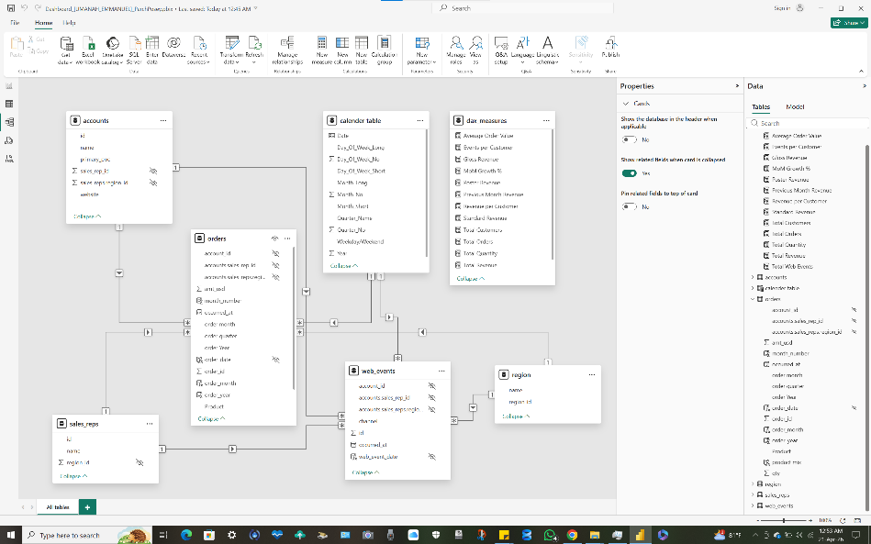
Challenges Overcome:
- Snowflake to Star Schema: Addressed data redundancy by merging keys into fact tables.
- One-to-One Conflicts: Resolved by building a custom Calendar table.
- ID Consistency: Maintained original table IDs to prevent link breakage, while hiding foreign keys for a cleaner user report.

